Arugula Pesto with Dried Tomatoes and Polenta

by Yael Bernier, Bernier Farms

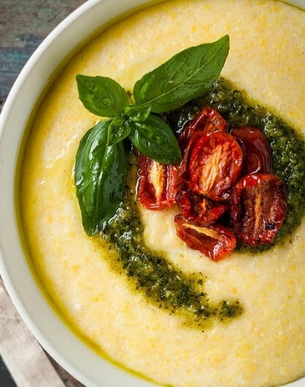
This recipe is loved by all of our family. It's especially good right now (Spring) because fresh pulled spring garlic is mellow and not as intense as it will be a month later as it cures. The cloves have a fleshy covering that does not need to be peeled off. That same covering will become a paper-like skin after the garlic is cured.

Ingredients:
10 cloves fresh spring garlic
1/2 cup dried tomatoes
1 cup walnuts
Juice from 1/2 lemon
1-1/2 lb arugula
Olive oil (enough to blend all the ingredients until smooth and slightly runny)
Parmesan cheese
Salt to taste
Polenta
Instructions:
Bring a pot of water to a boil. Wash the arugula and blanch in the boiling water for about 1 minute. Strain the arugula in a colander and let cool enough to squeeze out some of the liquid. I never squeeze it dry; I just eliminate some of the liquid.
Add the blanched arugula to a blender along with the garlic, walnuts, lemon juice, and 1-2 teaspoons of salt. Process the mixture while adding the olive oil until smooth and slightly runny.
Follow a basic polenta recipe. I use coarse-ground polenta and I like it slightly runny. I generally chop a bit of rosemary into the polenta as it cooks and I use olive oil instead of butter.
When the polenta is finished cooking, pour it into a large shallow bowl and top it with the arugula pesto. Sprinkle dried tomato pieces and parmesan cheese on top.

