Polenta with Vegetables and Egg

Chef Julia Farkas Gnall, Tierra Vegetables

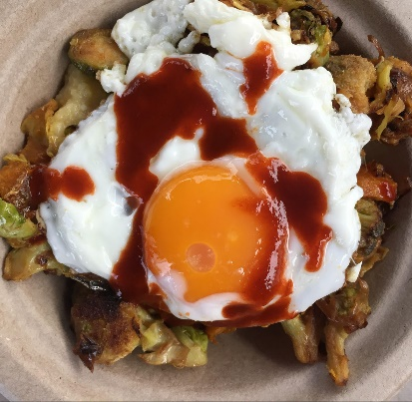
This is one of my favorite combinations of flavors that is all Tierra vegetables. I love this for any meal – breakfast, lunch or dinner. Enjoy!

Makes 4 servings

Ingredients:
(all ingredients for this dish are seasonally available at Tierra Vegetables)
1 cup Hickory King cornmeal
3 cups water
1/4 cup olive oil
2 tbsp salt
1 large celery root
1 large butternut squash
1/4 cup olive oil
2 bunches of greens like kale or spinach
3 cloves garlic
4 eggs
Aji panca hot sauce
Salt and pepper to taste
Instructions:
Polenta Instructions
Bring 3 cups of water to a boil. Once boiling, add salt and olive oil and pour the cornmeal into the boiling water while whisking constantly to prevent clumps. Smash one clove of garlic, add to the cornmeal and continue to stir until thickened. Turn flame to low and stir occasionally until very thick. Pour out into a heat-proof dish and smooth out with a spatula. Cool completely. (Can be made up to a day in advance.)
Once the polenta is cool, dice it to the same size as the vegetables. In a hot nonstick pan, pour a few drops of olive oil and crisp up the little pieces of polenta.
Roasted Vegetable Instructions
Preheat the oven to 400 degrees. Peel and dice the vegetables to the same size, toss in a bowl with the olive oil, salt, and pepper. Place on a sheet pan and roast for 30-40 minutes or until a little crispy. Mix with the crispy polenta.
Greens Instructions
Clean the greens and cut into ribbons. In a pan, warm olive oil and add 2 cloves of garlic until fragrant. Add greens and season with salt and pepper. Cook until wilted. Add on top of crispy polenta and roasted vegetables.
Cook the eggs over-easy in olive oil seasoned with salt and pepper. Place an egg on top of each serving and drizzle aji panca on top for added flavor and spice.

