Mandarin Cauliflower

Aaron Arabian, Chef at The Trading Post in Cloverdale

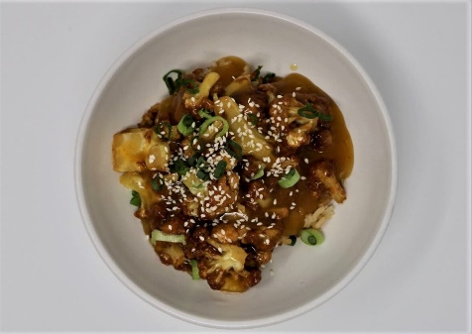
When we have really good cauliflowers, like the ones Rebecca grows at Lantern Farm, this is one of my favorite things to make. It is inspired by the orange chicken at a certain Chinese food fast food joint (you know you love it!) as well as the phenomenon of buffalo wings made with cauliflower. We like to use the mandarins, but any sweet citrus like Valencia orange, tangerine or even blood orange will work in this recipe. Serves 4

Ingredients:
2 medium or 1 large cauliflower
1 tbsp mandarin zest (from about 3 of them)
1 cup fresh squeezed mandarin juice (from 5-8 mandarins)
1 cup distilled vinegar
1 cup granulated sugar
1/4 cup soy sauce
1 dash toasted sesame oil
3 tbsp cornstarch dissolved in 3 tbsp water (slurry)
sesame seeds and sliced scallions, for sprinkling at the end
Instructions:
We are going to fry the cauliflower so if you have a tabletop fryer, get that going. Otherwise, heat up 1 inch of oil in a skillet with high sides, preferably cast iron. You want the oil temp to be 325.
The cauliflower should be cut into large, bite-size pieces - maybe an inch in diameter. Use florets and pieces of the stem too. All the smaller bits should be reserved for another use (they will burn in the oil). When the oil is at temp, fry the cauliflower in batches. Fry until the white has turned a deep golden brown, and the inside is cooked.
For the sauce, bring the sugar, juice, zest, vinegar and soy sauce to a boil. Cook for 5 minutes to reduce the sauce a bit, then whisk in the cornstarch slurry. It will thicken quickly, so continue to whisk as it boils and do not walk away. After 1 minute of boiling, the starch will have fully gelatinized. It should coat a spoon and anything else you dip into it. Hit it with a dash of sesame oil, then taste for seasoning. It should be sharply acidic and quite sweet. This can be made ahead of time. I like to make it in large batches, as it goes with all sorts of things. Add the fried cauliflower to the sauce and bring to a boil. Stir until everything is nicely coated and the cauliflower is warmed through. Serve over rice, sprinkled with sesame seeds and scallions. You won't miss the chicken, believe me!

