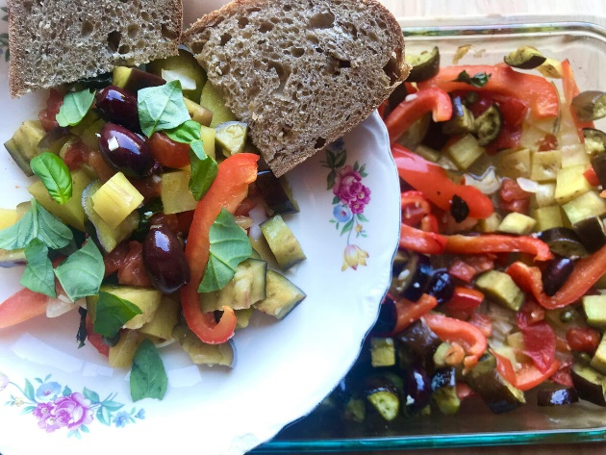
Cianfotta Italian Vegetable Stew
Ellen Shick
Blog: An Italian Dish
This southern Italian summer stew from Campania is similar to the French ratatouille. Commonly this is made in stages on the stovetop, but I love this oven method. It’s faster, all in one dish, and is just as yummy.
INGREDIENTS
¾ cup olive oil plus 3 tablespoons
1 onion, large dice
2 medium potatoes, diced
2-3 medium tomatoes, large dice (you can also use a 15 oz can whole tomatoes)
1-2 eggplants (1 globe or 2-3 small Italian style)
2 bell peppers, sliced (red, yellow, or green or any combination)
1 handful fresh basil leaves
2 cloves garlic, minced
salt, to taste
½ cup olives (optional)
2 Tbsp capers (optional)
INSTRUCTIONS
1. Preheat oven to 400° F
2. Spread 1 Tbsp olive oil in the bottom of a 9' x 13" baking dish.
3. Add onion, potatoes, and tomatoes and spread evenly.
4. In a separate bowl, mix eggplant, garlic, and bell peppers with ¾ cup olive oil. Salt to taste. Mix well to coat. (We use this quantity of olive oil to make sure the eggplant cooks completely.)
5. Pour the eggplant, garlic, bell pepper mixture over the onions, potatoes and tomatoes. Spread evenly. Tear basil leaves and scatter over the top. If using, top with olives and capers. Finally, broadcast 2 Tbsp olive oil over all.
6. Bake at 400° F for 20 - 30 minutes until all the vegetables are cooked through but not soggy. No need to stir while cooking. Check once or twice to prevent overcooking.
This dish can be served right out of the oven or at room temperature. It goes great with crusty bread. I have been known to serve this on top of toasted bread--bruschetta style. The possibilities are endless! Buon appetito!

