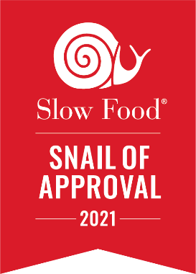
Snail of Approval Standards

Slow Food in Sonoma County envisions these standards as guiding principles to embodying core Slow Food values. We understand that practicing Slow Food values is a process based on commitment, passion, and practicality, not on a rubric of metrics. Therefore, applicants need only meet 83% of the criteria listed below to be considered for the Snail of Approval Each of the categories are ranked from 0-3 points with fractional points to be used. The average of the 3-person team (Snail committee member + 2 SF members at large) is calculated to determine approval / rejection status. A typical site visit lasts about 60 to 90 minutes.
Good food is fundamental: food must taste good and be good for us. This includes:
- the freshness, seasonality, regionality, and wholesomeness of ingredients;
- the care and craft with which the ingredients are handled;
- the health of consumers;
- and the extent to which cultural heritage and/or biodiversity is preserved.
Clean food is produced in a manner that does not harm the environment, animal welfare, or our health. This includes:
- the conservation of natural resources and mitigation of climate change;
- the quality of life of consumers, producers, and their neighbors;
- the welfare of animals, including farm animals and wildlife;
- and the employment of practices that are appropriate for the area in question.

Fair food means ensuring accessible prices for consumers, as well as fair conditions and pay for small-scale producers. This includes:
- the employment of fair labor practices and fair sourcing;
- fostering a work environment that promotes diversity, and that is safe for people of all races, ethnicities, gender identities, and sexualities;
- the fair compensation of producers, laborers, distributors, and others in the food system;
- and ensuring that physical, financial, and educational barriers do not inhibit the availability of high quality and culturally appropriate food to all.
Recipients Receive
- Snail of Approval decal(s) to be displayed at their place of business;
- A Snail of Approval icon for inclusion on websites, menus, newsletters;
- Be listed, along with a description of their products and services, on the Snail of Approval page of the Slow Food Sonoma County North & Russian River websites
- Be promoted on the Snail of Approval-Slow Food in Sonoma County social media.
Monitoring & Evaluation
Slow Food in Sonoma County monitors the integrity of Snail of Approval restaurants and artisans through ongoing feedback from Slow Food Sonoma County North and Slow Food Russian River members.
- Snail of Approval certification is valid for two years; renewal follows the initial process
- Applicants re-applying after 2 years do not have to pay the $35 fee.
Please contact us with any questions you may have about these standards by emailing us at snailofapprovalsc@gmail.com.

