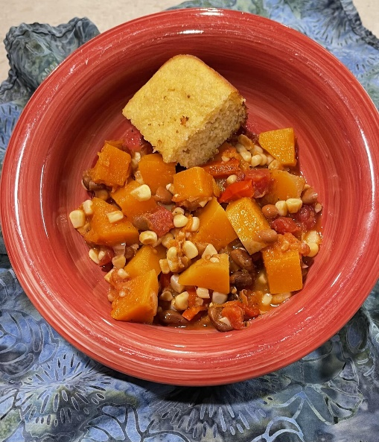
Three Sisters Stew

From Citizen Potawatomi Nation

Serves: 8 or more
Ingredients:
1 large butternut squash (about 2#), cooked and cubed (see cooking tips below)
2 tablespoons olive oil
1 medium onion, chopped
2 to 4 cloves garlic, minced
1 medium red bell pepper, cut into short narrow strips
14- to 16-ounce can diced tomatoes, with liquid
2 to 3 cups cooked or canned (drained and rinsed) pinto beans
16 oz. frozen corn kernels
1 cup chicken or vegetable stock, or water
2 teaspoons ground cumin
1 teaspoon chili powder
1/2 teaspoon dried oregano
Salt and freshly ground black pepper
1/4 cup minced fresh cilantro
Instructions:
Heat the oil in a soup pot. Add the onion and sauté over medium-low heat until translucent. Add the garlic and continue to sauté.
Add all the remaining ingredients except the last 2, and bring to a simmer. Simmer gently, covered, until all the vegetables are tender, about 20 to 25 minutes.
Add squash in for the last 15 minutes. Season to taste with salt and pepper. Sprinkle each bowl with fresh cilantro.
Cooking Butternut Squash
Remove stem from squash and cut in half lengthwise. Scrape out the seeds and fibers (clean the seeds for roasting, if you’d like). Place the halves, cut side down, in a baking pan (glass for microwave) and fill with 1/2” of water.
For oven: Preheat the oven to 375 degrees F. Bake for 40 to 50 minutes, or until you can pierce through with a knife, with a little resistance. When cool enough to handle, slice and peel, then cut into large dice.
For microwave: Microwave for 10-15 minutes until you can pierce through with a knife, with a little resistance. When cool enough to handle, slice and peel, then cut into large dice.

