Recipe of the Month: Fresh Corn & Black Bean Salad
This summer salad can be eaten as a main or side dish. Serves 3-6
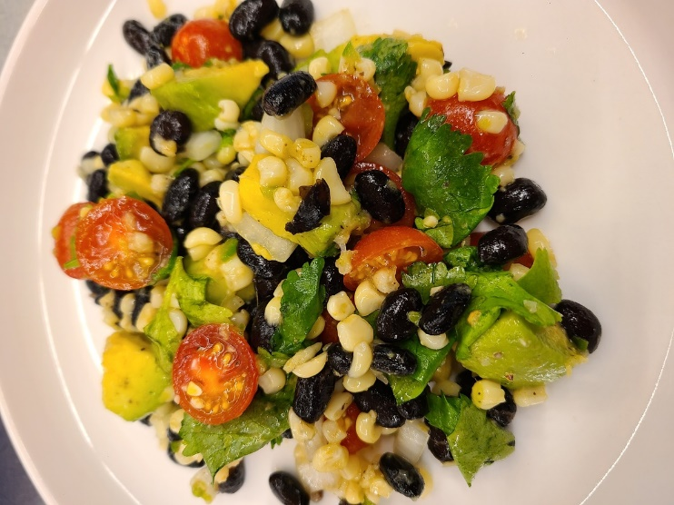
Ingredients
2-3 ears of corn, kernels removed (about 2 cups), or 1-15 oz can
2 cups cooked black beans (or 1-15 oz can)
½ small red onion, sliced and lightly chopped
2 cloves garlic, minced (or more if you love garlic!)
1 medium jalapeno, ribs & seeds removed, finely diced
1 cup sliced cherry tomatoes
1 avocado, chopped
½ bunch cilantro, de-stemmed
1 Tablespoon olive oil
2 Tablespoons freshly squeezed lime juice (about 1 lime)
½ teaspoon cumin
Salt and freshly ground pepper to taste
Procedure
Combine all the ingredients together in a large bowl. Adjust to your taste and season as needed.

