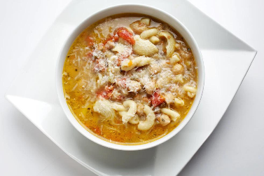
Pasta e Fagioli
Recipe courtesy of The Washington Post
4 servings; 9 cups

Ingredients
2 tablespoons best-quality extra-virgin olive oil, plus more for serving
1 cup finely diced onion
1/4 cup well-scrubbed, finely diced carrot (from 1/2 medium carrot)
1/4 cup finely diced celery (from 1 medium rib)
3 ounces pancetta, chopped
2 teaspoons minced garlic
2 bay leaves
1/2 cup white wine
6 cups no-salt-added chicken broth
2 (14.5-ounce) cans of a combination of no-salt-added beans (chickpeas, borlotti, cannellini, etc.), drained and rinsed
1/4 cup dried lentils, rinsed
1 cup canned Roma tomatoes with their juices, preferably an Italian brand, hand-crushed
1 tablespoon minced fresh rosemary
4 ounces (1 cup) dried mixed pasta, such as a combination of ditalini, cavatelli and conchigliette
Kosher salt
Freshly ground/cracked black pepper
1/3 cup freshly grated Parmigiano-Reggiano cheese, plus more for serving

Procedure
Heat the 2 tablespoons of oil in a large pot over medium heat. Once the oil shimmers, add the onion, carrot, celery, pancetta, garlic and bay leaves, stirring to coat. Cook until the fat from the pancetta renders out and the vegetables become translucent, about 7 minutes.
Add the wine and cook for about 10 minutes, until it has nearly evaporated. Add the broth, beans, lentils, the tomatoes and their juices and the rosemary. Increase the heat to high; cover and bring to a boil, then reduce the heat to medium-low and cook, uncovered, until the lentils are tender, 20 to 22 minutes.
Use a slotted spoon to transfer 1 cup of the bean mixture and a little liquid to a blender. Remove the center knob so steam can escape. Hold a paper towel over the opening. Puree until smooth.
Add the dried pasta to the pot, stirring to incorporate; increase the heat to medium-high. Boil until the pasta is tender but still firm to the bite; the cooking time will depend on the brand and shape of the pasta; figure about 12 minutes. The soup will thicken a bit by the time the pasta is cooked. Remove and discard the bay leaves.
Stir the pureed bean mixture into the soup. Season with salt and pepper to taste. Cook briefly, until heated through.
Remove from heat; stir in the Parmigiano-Reggiano. Let the soup sit for 5 minutes, then ladle it into individual bowls. Drizzle each portion with extra-virgin olive oil, then sprinkle with cheese.

