Tortitas: Veggie Fritters with Fresh Salsa
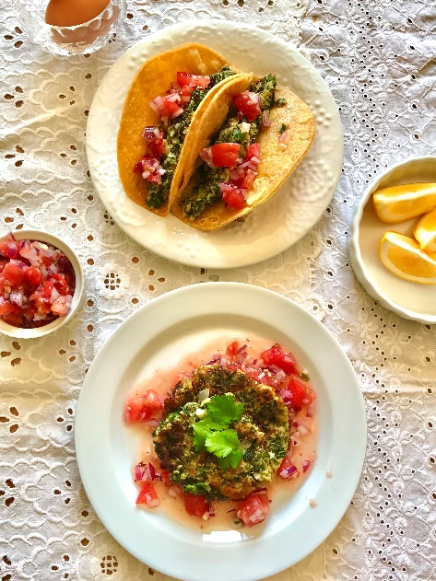

Tortitas are a pan-fried vegetable, egg, and cheese dish found in Mexican and South American cuisines.
The chefs at Tierra Vegetables shared their recipe with us, and the dish utilizes some of their early spring greens: baby kale, rainbow chard, and cilantro. They suggest topping with a fresh tomato and red onion salsa. Tortitas can be made with any type of greens, and typically chard (acelga) or purslane are used.
The following recipe gives two cooking and serving options: as a pan-fried fritter or as a yummy taco filling.

Ingredients
For the Tortitas
1 bunch baby kale
1 bunch rainbow chard
½ head cauliflower
1 small bunch cilantro, chopped
1/2 medium red onion, chopped
4 eggs
8 ounces queso seco (hard Mexican cheese), grated
1 Tbsp. salt + 1 tsp.
3 Tbls. olive oil

For the salsa
1 large tomato, chopped
½ red onion, chopped
2 cloves garlic, minced
1 tsp. salt
a few turns of freshly ground black pepper

Directions
Make the salsa by mixing together the chopped tomato, red onion, garlic, salt, and pepper. Set aside. Reserve 2 Tbsp. for garnish.

Finely chop chard, baby kale, and cut the cauliflower into florets. Add 3 cups water to a large pot and bring to a boil. Add 1 Tbsp. salt and drop in the greens and cauliflower. Blanch for one minute then remove. Use the blanching water for a soup broth or other use.

Then in a food processor, mix greens, cauliflower, chopped onion, 1 tsp. salt, and cilantro. Pulse a few times to break up the cauliflower and greens just a bit. Do not process into a paste.

Add to a large mixing bowl and stir in the eggs and Queso seco. Mix well to combine. The batter will be moist.

To make Tortita fritters:
Heat the olive oil in a heavy saucepan or skillet on medium-high heat. Drop the batter by large spoonfuls and fry them in hot oil just like potato pancakes. Cook for 3 minutes per side until cooked through. When done on both sides, remove the Tortita from the heat. Then add the salsa to the pan, put the tortitas back in the pan to cook them in salsa for 1-2 minutes. Serve with white rice and top with more salsa and a sprig of cilantro.

To make taco filling:
Heat the olive oil in a heavy saucepan or skillet on medium heat. Add ½ of the batter at once and cook for 3 minutes before stirring. Stir the batter and cook for an additional 3 minutes until cooked through. Set aside and cook the other half of the batter. Serve inside a corn tortilla and garnish with fresh salsa and cilantro.

