Sorrel and Meyer Lemon Pesto
Created by Sheana Davis and Ben Sessions, The Epicurean Connection
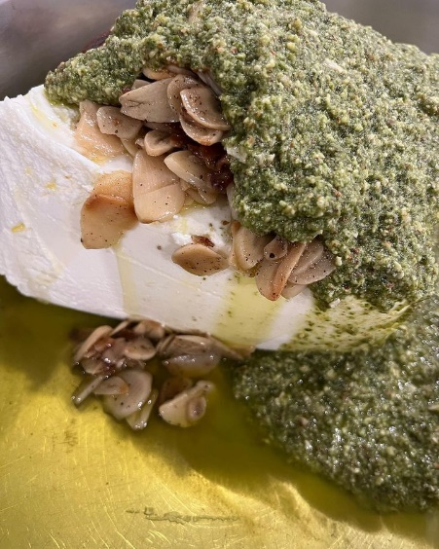
Yields 1-1/2 cups
Ingredients
1 cup Sorrel leaves, stems removed
1 tablespoon Sonoma-grown garlic, minced
1/4 cup Sonoma Meyer Lemon juice
1 teaspoon Sonoma Meyer Lemon zest
1/2 cup olive oil
1/2 teaspoon salt
1/2 teaspoon fresh ground black pepper
Procedure
Place ingredients in food processor and blend until smooth. Taste and adjust flavors. Serve over Delice de la Vallee or fresh cheese of your choice.

